OPTION 1: BigStar Circus Venue 3hr Birthday Package
Venue Party Package Example
Schedule (timetable is indicative; final timing confirmed upon booking):
- 9:30– 10:00 AM | Setup & decorations (supplied by client) - 30min
- 10:00 – 11:30 AM |Welcome, entertainment and Circus / Aerial play, including balloon twisting or any selected add-ons. Rhett will also be your party DJ, providing music throughout the celebration (included in the package). – Duration: 1.5 hours
- 11:30 – 12:00 AM | Cake & presents (supplied by client) 30min
- 10:40 – 11:00 AM | Goodbyes & cleanup 30min
Activity Options Add On:
- Jumping Castle $100 ( Parents are required to assist with supervision during the event.
- Balloon Twisting $100
- Face Painting $250 - ( Hire contractor ) 45min
Inclusions: Flat Rate (up to 10 children): $680
- 1 x Host / Trainer / Performer
- Tables, chairs, fridge access, restrooms, and venue hire
- Safety rules: No shoes or food on gymnastics mats. Please bring your own food, drinks, and decorations.
- Please read T&C attached in this email and see Birthday party invite for you to send out
- A $200 deposit is required to secure your booking. The remaining balance is to be paid one week prior to the party.
- 💰Additional children (up to 20 total): + $250
(Includes one additional staff member and extra equipment)
- Additional children (up to 30 total maximum): + $450
(Includes two additional staff members and extra equipment)

OPTION 2: We Can Come to You – “Mr Kaboodle” Party Packages
1.5 Hour Mr Kaboodle Show Package 1 – $500 +gst
- 30 min interactive circus show
- 30 min interactive balloon twisting show
- Fun party games (bubble party, treasure hunt, limbo – time permitting)
- Music provided
- Includes 1 performer & 3x3 ring mat
OR
1 Hour Mr Kaboodle Balloon Twisting Package 2 – $300 +gst
- 1 hour interactive balloon twisting
- Fun party games (bubble party, treasure hunt, limbo – time permitting)
- Music provided
- Includes 1 performer & 3x3 ring mat
....................................................

We also provide a digital and print version invitation so waivers can be signed and it's one less thing for you to organise!
Please see the Terms and Conditions attached. Accepting to move forward with the party means that you agree to these terms and conditions.

And don’t hesitate to contact me with any questions. We are happy to tailor packages to your needs, just ask!

Jackie
Admin Team Monday - Wednesday
📍 Address: Unit 1/14 Harper St, Molendinar QLD 4214
📞 0489 188 179
📧 admin@bigstarcircus.com.au
🌐 www.bigstarcircus.com.au
📸 Follow us on Instagram & Facebook: @Bigstarcirscus
🎪 Bringing the joy of circus to all! 🎭✨
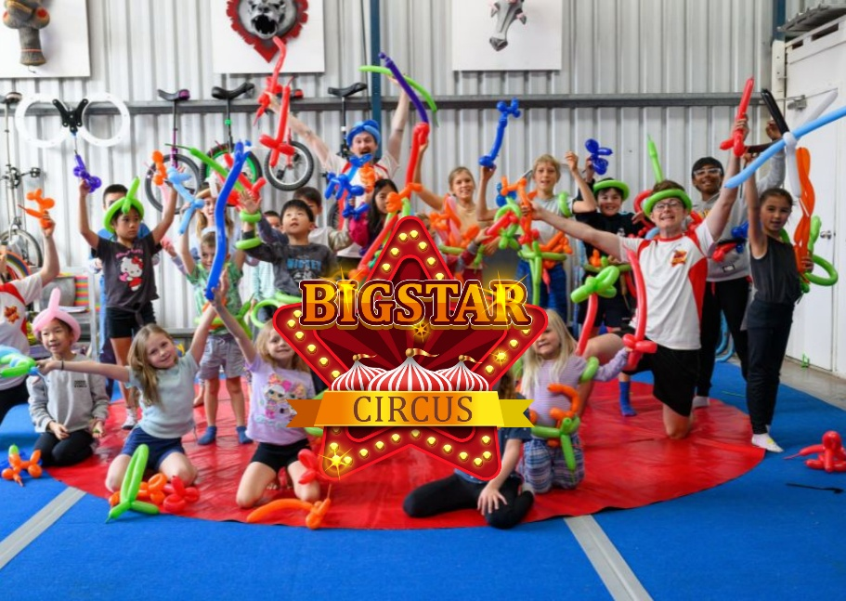

Birthday Party Travel Costs
up to XX km + $Extra cost
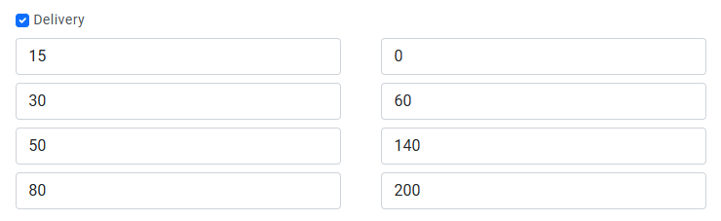

Birthday Invitation
Thank you for your deposit including the cleaning and for (Child’s Name’s) birthday party on (Insert Date) — we’re excited to celebrate with you!
Attached are the video and printable invitations with all the party details, including the waiver link for guests to complete before the event. Please check in with us one week prior to confirm final guest numbers.
The remaining balance is required before the party date to ensure everything runs smoothly. We’ll send a reminder closer to the time.
If you have any questions, feel free to reach out — we look forward to hosting a fantastic party!
Birthday RSVP Response to signed waivers
OPTION 1 PRIOR
Thanks for confirming attendance at the BIGSTAR CIRCUS birthday party 🎉
We’d also love to invite your child to take advantage of our 3 x FREE Trial Classes - it’s a great way to experience the fun beyond the party!
You can view our timetable here:
https://bigstarcircus.com.au/Classes
Just let me know which classes you’d like to try, and I’ll help get everything organised. 🎪✨

OPTION 2 post party
Thanks for attending XXXX birthday party at BIGSTAR CIRCUS 🎉
We’d also love to invite your child to take advantage of our 3 x FREE Trial Classes - it’s a great way to experience the fun beyond the party!
You can view our timetable here:
https://bigstarcircus.com.au/Classes
Just let me know which classes you’d like to try, and I’ll help get everything organised. 🎪✨

